Walk 42 Herefordshire Trail
Last walked in July 2018

Description. 7 km (4.3 miles) Taking a compass might be useful. A pleasant walk along tracks, minor roads and farmers fields.
Start. Wacton Court. Explorer Map 202 Grid 615574.
Directions from Whitecross Roundabout (Turn milometer to zero). Take the A4110 Canon Pyne (Three Elms road) for 1 mile and TR at the traffic lights onto the A4103 Worcester (Roman road). Straight across the first roundabout (2m), and the second roundabout, then at 3.8 miles you TL on the A465 to Bromyard. Go straight across the next roundabout (9m), and continue on to Bromyard. At a T-junction (15.1m) you TL onto the A44 for Leominster. At 18.5 miles, next to a small garage, you TR for Wacton and go along a narrow one way No Through Road. Park up along the grass verge by Wacton Court (19.2m), which is on your left.

1. Wacton Court. Continue along the road, (passing Wacton Grange on your R), the tarmac deteriorates into a farm track and at the end you go thru a gate into a field F1. Turn half L and cross the field to go thru a gate and under disused railway lines unto F2. Go straight across this cropped field and thru a small wooden gate and continue along an enclosed track. Go thru a small metal gate, (down to the L is a small bricked footbridge) and continue on, to go thru wooden gates and bearing slightly R to reach a road by Butterley Brook cottage.

2. Butterley Brook Cottage. Cross the road and walk up and along an enclosed well defined farm track for just over a km. The track then bends R and goes on past High Acres farm (R), and further on the track becomes a tarmac road. You go past Clark’s Croft Cottage (L), and further on you reach a prominently displayed public footpath sign post, (the drive on your L goes to Velvet Stone Cottage).

3. Velvet Stone Cottage. TR, go thru a gate and continue along the L field edge of F3. You are now going along part of the 153 mile long Herefordshire Trail. Go over a stile and walk along L edge of F4. Thru a gate/stile and continue along F5. Thru gate (a farm building is on the R) and continue along F6. Thru double wooden gates and onto a road. TR, continue along the road and pass Little Street Field farmhouse (L) to reach a fork in the road. Take the L fork and continue on, to pass Street Field Farm (R) where the road turns into a farm track. Go thru a gate onto a road and TR.

4. Cattle Grid. Pass over a cattle grid. Continue down the road and cross over another cattle grid and TL, (you are now going back the way you came, along Butterley Brook, which is on your R). Continue along the dirt track, go thru a small wooden gate and into an open field F2. Cut straight across the field and under the old railway bridge, thru a metal gate into F1. Go up this field to reach the top R hand corner to go thru a small gate onto an enclosed dirt track. Walk up and along to reach the car.

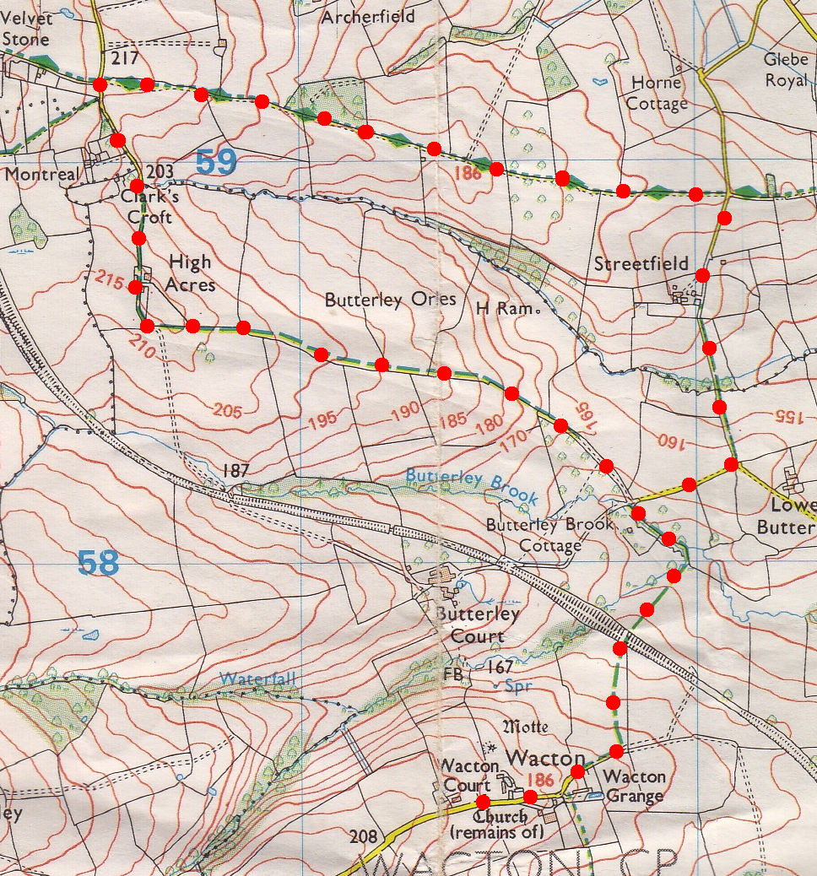

1
2
4
3

